1. Quick Start
   1. Equipment Configuration
      1. Device connection



Fig Front panel of KV-8000

[Equipment list]

・PC

・CPU unit: KV-8000

・Communication unit: KV-XL202

・Power unit: CA-U4

・Source meter: 2400s

・RS-232c cable (Need to cutting)

・USB cable

・Ethernet cable

・3-terminals power cable

Set the mode switch on the KV-8000 to PROG (Fig 1).

Connect the above devices as shown in Fig 2.

After cutting the RS-232c cable, attach the cut section to the KV-XL202 Port1. The RS-232c cable currently in use can be connected with the color pattern shown in the lower right of Fig 2. It is recommended that a continuity check be performed when changing cables.

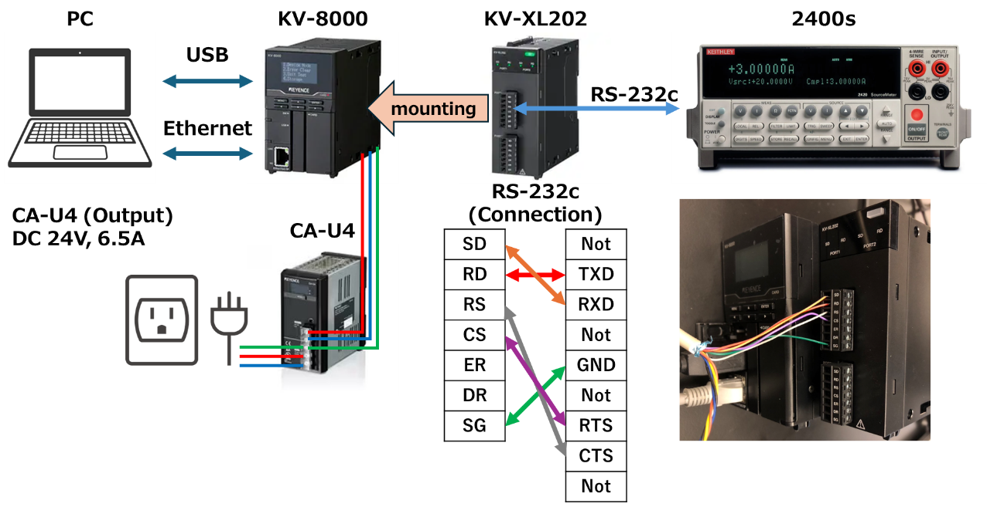

Fig Device connection

屋内, テーブル, ビデオ, ゲーム が含まれている画像

AI によって生成されたコンテンツは間違っている可能性があります。

Fig Photo of actual configuration

* + 1. 2400s Settings

[Communication settings]

1. Press the Menu button.
2. Select Communication and press Enter
3. Select RS-232 and press Enter
4. Select BAND and press Enter. Select 9600 and press Enter.
5. Select BITS and press Enter. Select 8 and press Enter.
6. Select PARITY and press Enter. Select EVEN and press Enter.
7. Select THERMINATOR and press Enter. Select <CR+LF> and press Enter.
8. Select FLOW-CTRL and press Enter. Select XON-XOFF and press Enter.
9. Press the Exit button twice to return.

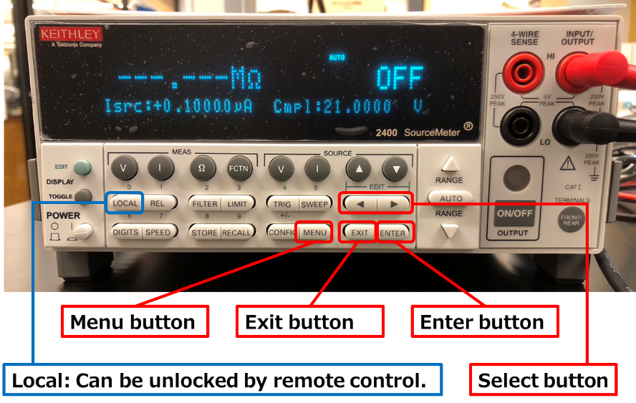

Fig Front panel of 2400s

* 1. Create KV-studio Project

1. Launch KV-studio.
2. Click on [File] -> [New project].
3. Enter Project name, PLC model, Project location. (Fig 5)
4. Click OK to create the project.
5. When the “Automatically set the operation recorder setting?” dialog box appears, select Yes. (*This setting is optional.)
6. When the “Setup unit setting info now?” dialog box appears, select No.

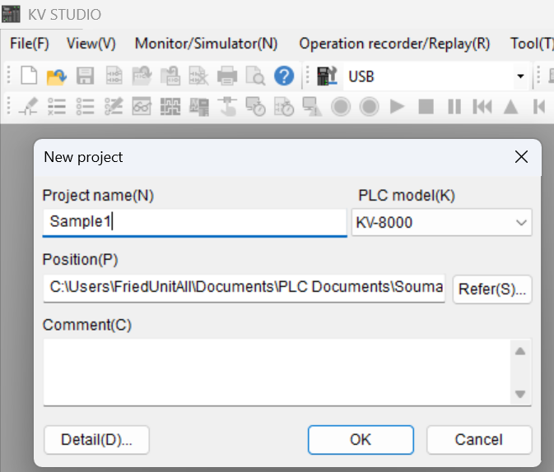

Fig Create New Project window

* 1. Configure PLC Settings

1. Click on [Tool] -> [Clear PLC].
2. Clear PLC: Select a Clear All and Execute.
3. Project tree: Right click on [Unit configuration] -> Click on [Unit Editor].
4. Unit Editor: Click on [File] -> [Read Unit config. from PLC].
5. Unit Editor: When the “Unit settings are read in the initialization status.” Dialog box appears, select Yes.
6. Unit Editor: Select KV-8000 and Set [FTP server] to “Used”. (Fig 6)
7. Unit Editor: Select KV-XL202 and Change to the following settings. (Fig 7)

・Port1, Operation mode: Select “Non-procedure mode”.

・Port1, Device allocation: “DM”. (default)

・Port1, Interface: “RS-232C”. (default)

・Port1, Baudrate: “9600bps”. (Match with 2400s settings)

・Port1, Data bit length: “8 bits”. (Match with 2400s settings)

・Port1, Start bit: “1 bits”. (default)

・Port1, Stop bit: “1 bits”. (default)

・Port1, Parity: “Even”. (Match with 2400s settings)

・Port1, Checksum: “none”. (default)

・Port1, RS/CS flow control: “ON”. (Match with 2400s settings)

1. Unit Editor: Click on [Apply]. And click on [OK].

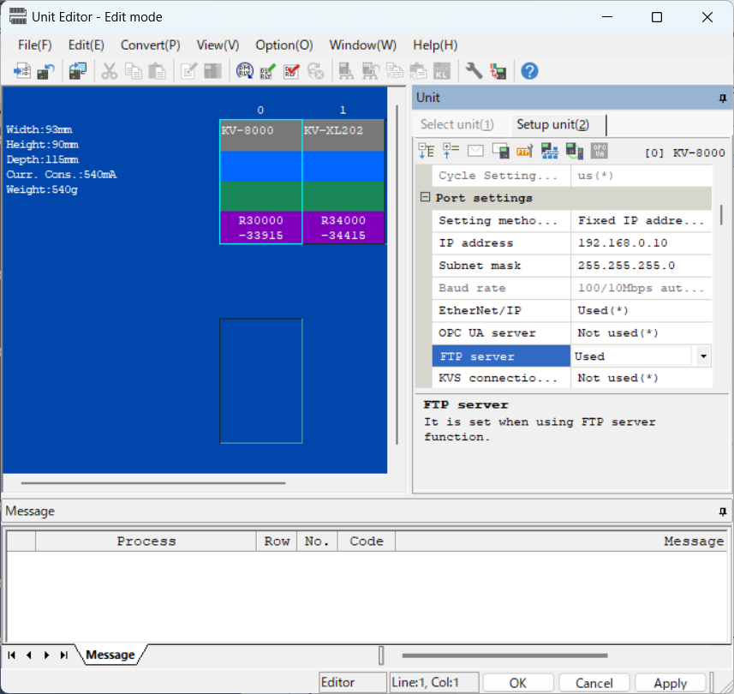

Fig Configuration of KV-8000

グラフィカル ユーザー インターフェイス

AI によって生成されたコンテンツは間違っている可能性があります。

Fig Configuration of KV-XL202

* 1. Register unit device

グラフィカル ユーザー インターフェイス, テキスト, アプリケーション

AI によって生成されたコンテンツは間違っている可能性があります。

Fig Device Comment

1. Click on [View] -> [Device comment edit window].
2. Device comment edit: Click on [Detail].
3. Device comment edit: Click on [Register unit device].
4. Register unit device: Select KV-8000 and KV-XL202.
5. Register unit device: Click on [Reg].
6. Device comment edit: Verify that the unit device is registered. And exit. (Fig 8)
   1. Create a Ladder Program

Import a basic program already created. The sample projects referenced exist in the following directories.

[Sample project]

C:\....\PLC_CommunicationTo2400S\Documents\Sample1\Sample1.kpr

1. Writing: recorder setting: continue sending(No: this setting is optional.)
2. A
   1. Load settings from PLC
   2. Writing settings and programs
   3. Displaying device values
   4. RS-232c communication of KV-XL202
3. Aaa
4. Aaa
5. Aaa